Taco Tom’s Admin Page

Business Name: |   Taco Tom’s Lonchera
Created By: | Jasmine Biri

Table of Contents
Application Design and Testing 4
Class Design 4
UI Design 7
Unit Test Plan 11
Introduction 11
Purpose 11
Overview 11
Test Plan 12
Items 12
Features 13
Deliverables 13
Tasks 13
Needs 14
Pass/Fail Criteria 14
Specifications 16
Procedures 17
Results 17
Hosted Web Application 20
Hosted Web Application Link: 20
Gitlab Repository and Branch History 20
GitLab Repository Link: 20
GitLab Branch HIstory: 21
User Guide for Initial Setup and Running the Application 22
Introduction 22
Pre-requisites 22
Clone the project from Gitlab and run it with docker 22
User Guide for Running the Application from User Perspective 24
Introduction 24
App Preview 24
Login 24
Registration 25
Home Page 25
Generate Player Report 26
Sell Page 27
Upgrades Page 27
Prestige Page 28
Leaderboard Page 29
Settings Page 29
Panopto Video Link 30

Taco Tom’s Admin Page – User Guide

Introduction

Purpose
The Taco Tom’s Admin Page allows authorized staff to manage the online menu and basic site content. From this page you can:
- Add new menu items with photos and descriptions
- Edit existing items
- Mark items as available/unavailable
- Remove items that should no longer appear on the site
Only users with admin credentials should have access to this page.

Accessing the Admin Page

Logging In
- Open a web browser (Chrome, Edge, Safari, Firefox).
- Go to:
https://tacotomslonchera.com/admin/admin-login.html
- Enter your username and password.
- Click Log In.
If your login is successful, you’ll be redirected to the main admin dashboard at:
- https://tacotomslonchera.com/admin/admin.html
If you see a login error, check that:
- Caps Lock is off.
- You’re using the correct username and password. Both fields are case-sensitive.
- You’re on the secure site (URL starts with https://).

Admin Layout Overview
The admin page is divided into two main sections:
- Left sidebar:
  - “Add New Menu Item” form
  - Fields for name, description, price, category, availability, and optional photo upload
  - “Add Item” button to create a new item
- Main content area:
  - List of existing menu items displayed as cards/rows
  - Each row shows:
    - Item image or “No Image”
    - Name and description
    - Category (e.g., Main, Sides, Drinks)
    - Availability toggle (checkbox)
    - Edit and Delete buttons
At the top, there is a small Logout button that signs you out of the admin area.
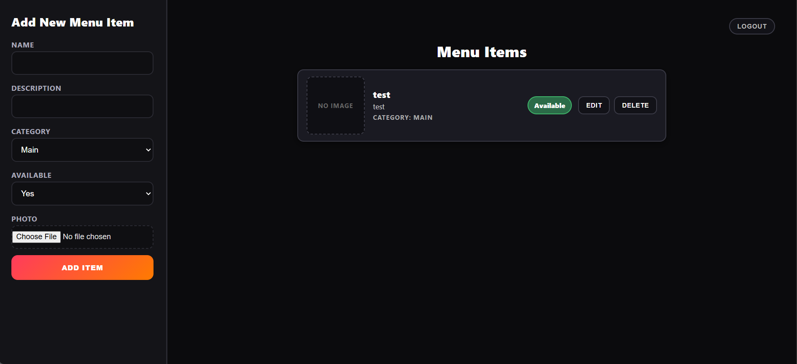

Managing Menu Items

Adding a New Item
- In the left sidebar, find the Add New Menu Item form.
- Fill in the fields:
  - Name (required): The item’s name (e.g., “Carne Asada Taco”).
  - Description (optional): Short description of the item.
  - Category (required): Choose from the dropdown (e.g., Main, Sides, Drinks).
  - Availability (required): Choose whether the item is available (Yes/No).
  - Photo (optional): Click “Choose File” to upload an image. If no photo is selected, the item will appear as a text-only item.
- Click Add Item.
- If the item is created successfully:
  - A success message appears (toast notification).
  - The new item will appear in the list in the main content area.
If an error message appears, check that all required fields (Name, Category, Availability) are filled correctly.

Editing An Existing Item
- In the main content area, find the item you want to edit.
- Click the Edit button on that item’s row.
- An Edit Item modal window will open.
- Update any of the fields:
  - Name
  - Description
  - Category
  - Availability (Yes/No)
  - Photo (upload a new file if you want to replace the existing image)
- Click Update in the modal.
- On success:
  - The modal will close.
  - The item in the list will refresh with the updated information.
  - A confirmation message will appear.
If the update fails, read the error message shown and verify the fields are valid.

Toggling Availability
Use this when an item is temporarily sold out or coming back:
- Locate the item in the list.
- Find the Available toggle (checkbox) on the right side of the row.
- Click the checkbox to:
  - Check = Available
  - Uncheck = Not available (item will be hidden from the public menu)
- Changes are saved automatically. If anything goes wrong, a small error message will appear.

Deleting An Item
Only delete items that should never appear again (for temporary changes, use availability instead).
- Find the item in the list.
- Click the Delete button.
- A red confirmation banner will slide down at the top of the screen.
- Choose:
  - Confirm to permanently delete the item, or
  - Cancel to keep it.
- After confirming:
  - The item will be removed from the list.
  - It will no longer appear on the public menu.
This action cannot be undone from the admin page.

Logging Out
To sign out of the admin area:
- Click the Logout button in the header of the admin page.
- You’ll be redirected back to the admin login screen.
- Close the browser tab if you’re on a shared or public computer.
Logging out helps keep the admin area secure.

Troubleshooting

I can’t log in
  - Check username/password spelling and capitalization.
  - Make sure you’re on https://tacotomslonchera.com/admin/admin-login.html.
  - If you still can’t log in, contact the site owner to reset your credentials.

Menu items are not updating on the public site
  - Refresh the public menu page.
  - Confirm the item is Available in the admin list.
  - If the problem continues, note the time and what you tried, and report it.

Photos are not appearing
  - Make sure you selected a file before saving.
  - Use common formats like JPG or PNG.
  - If the upload still fails, try a smaller image file.

